|  |  |
| --- | --- |
| 3 |  |
|  |  |

**404 Talent not Found:** Reconfiguring GBS Branding to Recruit and Retain Digital Innovators.

Jaroslava Bosa Strolena, Kateřina Mašková, Petr Velikovský,

Frederic Cote, Petra Filipi

mentor: Rudolf Zvánovec

ABSL Fusion Leader Programme

# Table of Contents

[1 Table of Contents 2](#_Toc180600630)

[2 Introduction 4](#_Toc180600631)

[2.1 Problem statement 4](#_Toc180600632)

[2.2 For whom is this strategy? 4](#_Toc180600633)

[3 Czech Republic GBS market overview 6](#_Toc180600634)

[3.1 Czech Service Centers overview – industry landscape 6](#_Toc180600635)

[3.2 The Impacts of Work from Home on Business Service Centers 9](#_Toc180600636)

[3.3 Future Predictions and Talent Strategies 11](#_Toc180600637)

[4 Trends – Impact on the future talent pool 12](#_Toc180600638)

[4.1 Demographics trends 12](#_Toc180600639)

[4.1.1 Aging of the population 12](#_Toc180600640)

[4.1.2 Migration flows 14](#_Toc180600641)

[4.1.3 The Czech Republic's migration policy strategy 14](#_Toc180600642)

[4.1.4 Integration law 15](#_Toc180600643)

[4.1.5 Conclusions and recommendations 1: 15](#_Toc180600644)

[4.2 Technology trends 18](#_Toc180600645)

[4.2.1 EU’s Technology trend: The rise and fall of hardware versus software. 19](#_Toc180600646)

[4.2.2 Conclusions and recommendations 2: 21](#_Toc180600647)

[4.3 Industry-Specific BPO Trends 22](#_Toc180600648)

[4.4 POLITICAL/LEGAL/IMPACT and ATTRACTIVITY OF EU 23](#_Toc180600649)

[4.4.1 Gerontocracy 24](#_Toc180600650)

[4.4.2 National strategy of the Czech Republic for 2030 25](#_Toc180600651)

[4.4.3 Location and EU attractivity for investors 26](#_Toc180600652)

[4.4.4 Conclusions and recommendations 3: 29](#_Toc180600653)

[4.5 Main Economic Takeaways for Czechia 30](#_Toc180600654)

[4.5.1 EU Green Deal Industrial plan impact: 30](#_Toc180600655)

[4.5.2 Tax Efficiency and Compliance 31](#_Toc180600656)

[4.5.3 Conclusions and recommendations 4: 32](#_Toc180600657)

[4.5.4 Benefits for the Global Business Service (GBS) Centers Industry from EU's 33](#_Toc180600658)

[4.5.5 Underlying issues: 34](#_Toc180600659)

[4.5.6 Trend: Poor investment decisions in infrastructure 37](#_Toc180600660)

[4.5.7 Conclusions and recommendations 5: 42](#_Toc180600661)

[4.6 Business shared services trend in Czech Republic 44](#_Toc180600662)

[4.6.1 Conclusions and recommendations 6: 45](#_Toc180600663)

[4.7 What else can impact the future of Czech Service centers? 46](#_Toc180600664)

[4.8 Political and legal system in the Czech republic 49](#_Toc180600665)

[4.8.1 Conclusions and recommendations 7: 50](#_Toc180600666)

[4.9 Branding: Setting targets, budget, and resources 51](#_Toc180600667)

[4.10 Sustainment: Measure the success and react quickly 54](#_Toc180600668)

[4.10.1 Conclusions and recommendations 8: 58](#_Toc180600669)

[4.10.2 Conclusions and recommendations 9: 59](#_Toc180600670)

[4.10.3 Conclusions and recommendations 10: 59](#_Toc180600671)

[4.11 References 60](#_Toc180600672)

# Introduction

Attracting and retaining talent is a notorious problem for employers in Czech Republic and Business centers sector is no exception to this challenge. The arrival of a new digital era represents another dimension to this complexity. The talent needed in Business centers is not only equipped by advanced hard/soft skill and typically multilingual, but also capable to navigate the changing digital innovations environment which is impacting all sectors of corporate company. How to secure internal readiness of Czech Business Centers to respond to the fast-evolving digital needs? Is there a need to change talent acquisition and retention strategies in order to secure the talent which is agile to embrace innovations?

## Problem statement

In this paper, we analyze trends which are to be considered towards the future of talent availability within the Czech market and specifically we seek a reply to a question **what the optimal 3-year employer branding strategy for existing corporate and multifunctional Business Service Center is based in Czech Republic to acquire/retain/develop employees embracing and delivering digital innovation.** The purpose is to provide a toolkit for Service Centers leadership for reflection and self-assessment on their current and intended future team readiness for delivering on digital innovation.

The strategy timeline of 3 years was selected intentionally. The digital environment is evolving very quickly and to secure the required agile and sustainable environment, it is necessary to reflect on both internal readiness and culture, as well as external branding.

Digital innovation we define as the process of utilization of digital technologies and strategies to create new or improved products, services, processes, and business models. It involves leveraging digital tools and platforms to drive transformation, enhance customer experiences, and generate value.

## For whom is this strategy?

In the fast-paced digital age, the demand for skilled talent capable of driving digital transformation has never been higher. For Czech business service centers aiming to thrive in this digital landscape, the importance of employer branding cannot be overstated. A compelling employer brand serves as a beacon, attracting the workforce ready to embrace digitalization and propel organizations towards success.

**With this paper, we would like to give recommendation and basic guidance on how to tackle this topic for existing corporate and multifunctional Business Service Centers based in the Czech Republic.**

Czech business service centers, nestled in the heart of Europe, are strategically positioned to harness the power of digitalization. With their robust infrastructure, skilled workforce, and favorable business environment, these centers have the potential to become hubs of digital innovation and excellence. However, to realize this potential, they must first attract and retain top digital talent—a task made possible through effective employer branding.

At its core, employer branding is about shaping the perception of an organization as an employer of choice. In the context of Czech business service centers, a strong employer brand communicates the center's commitment to digital innovation, technological advancement, and employee development. It showcases the center as a dynamic and forward-thinking workplace where digital talent can thrive and make a meaningful impact.

One of the primary benefits of a compelling employer brand is its ability to attract digital talent who are eager to contribute to digitalization efforts. In a competitive job market where skilled professionals have numerous options, a strong employer brand sets Czech business service centers apart from the competition. It signals to digital talent that the center is committed to investing in digital initiatives, providing opportunities for growth and advancement, and fostering a culture of innovation and collaboration.

Moreover, a strong employer brand helps Czech business service centers retain digital talent by creating a sense of belonging and purpose. Employees who feel valued, supported, and engaged are more likely to stay with their organization and contribute their best efforts towards digitalization efforts. A positive employee experience, coupled with opportunities for skill development and career advancement, enhances retention rates and strengthens the center's digital capabilities.

Furthermore, a compelling employer brand enhances the center's reputation within the digital community, attracting attention from top digital talent both locally and internationally. This not only expands the talent pool available to the center but also fosters collaborations and partnerships with other digital organizations, driving innovation and competitiveness.

In conclusion, employer branding plays a pivotal role in helping Czech business service centers attract the workforce ready for digitalization.

# Czech Republic GBS market overview

## Czech Service Centers overview – industry landscape

The Czech Republic has emerged as a significant player in the service center industry, particularly in Central and Eastern Europe. The Czech Republic has seen a significant increase in the number of service centers established by multinational companies in recent years employing over 175 000 people which makes this sector the largest business sector in the country. These centers provide a wide range of services, including IT, finance and accounting, customer support, HR, and more. (ABSL: ABSL REPORT 2024 [online]. Available on: <https://absl.cz/report-2024/>)

The Czech Republic boasts a highly educated and skilled workforce, with a strong emphasis on technical and language skills. Many universities and technical schools in the country offer programs tailored to meet the needs of the service center industry. The country's central location within Europe, coupled with its well-developed infrastructure and skilled workforce, makes it an attractive destination for service center operations. Proximity to Western European markets and a favorable business environment further contribute to its appeal. While labor costs in the Czech Republic are higher than in some other outsourcing destinations, they remain competitive compared to Western European countries. Companies can benefit from cost savings while still maintaining high-quality service delivery. The service center industry in the Czech Republic is diverse, with companies from various sectors establishing operations. Major industries represented include technology, finance, manufacturing, automotive, pharmaceuticals, and shared services. (ABSL: ABSL REPORT 2023 [online]. Available on: <https://absl.cz/report-2023/>)

In 2024 and the years to follow, the Czech Republic’s job market is set to undergo significant transformations, driven by technological advancements, shifts in workforce dynamics, and changes in the global economic landscape. Local organizations and government bodies in the Central and Eastern European (CEE) region have sharpened their expertise in fostering investor relationships. They are now actively offering grants and incentives to attract large, shared service centers and manufacturing plants to well-established business hubs. This has resulted in a substantial presence of multinational companies in the region, with more expected to join. However, this increase in competitiveness among CEE countries may lead to widespread skill shortages, particularly in fields such as IT, research and development (R&D), life sciences, and engineering roles, according to Alex Shteingardt of Hays. (TEAM JOBSPIN: Czech Job Market Trends in 2024: AI Impact, Emerging Job Types, and Employment Outlook [online]. Available on: <https://www.jobspin.cz/2023/10/czech-job-market-trends-in-2024-ai-impact-emerging-job-types-and-employment-outlook/)>

According to the ABSL Report 2024, in the foreseeable future, Czech centers are placing considerable emphasis on the recruitment and retention of personnel with essential skills and roles, both in the upcoming year 2025 and as they project towards the end of 2026. Looking further ahead to 2026, there's an increased focus on the critical tasks of cost management and value creation. Equally significant is the prioritization of employee well-being and resilience, which has become even more paramount compared to the previous year. (ABSL: ABSL REPORT 2024 [online]. Available on: <https://absl.cz/report-2024/>)

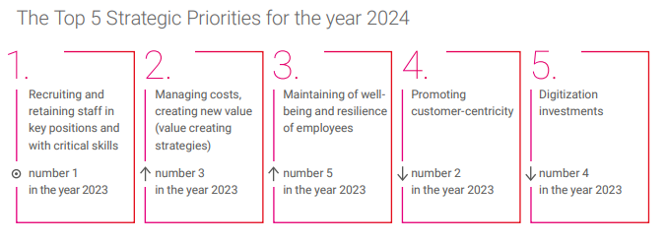

*Picture 1. ABSL report 2024 – Strategic Priorities for 2024*

In today's rapidly evolving digital landscape, organizations across industries are experiencing a profound shift in the way they operate and engage with their workforce. As businesses embrace digital transformation initiatives to stay competitive and innovative, the need for a digitally skilled workforce has never been more critical. In this context, the role of employer branding in attracting top talent who are ready for digitalization cannot be overstated.

As Czech service centers navigate an evolving global landscape, they face a series of challenges that will shape their operations and strategies in the coming years. Key among these are adapting to rapid technological changes, managing remote and hybrid work models, enhancing cybersecurity, balancing economic pressures with sustainable practices, and navigating geopolitical uncertainties. These challenges necessitate strategic foresight, flexibility, and a commitment to continuous innovation and learning. The future trends emerging from these dynamics will significantly impact talent acquisition and retention strategies in the Czech business services sector.

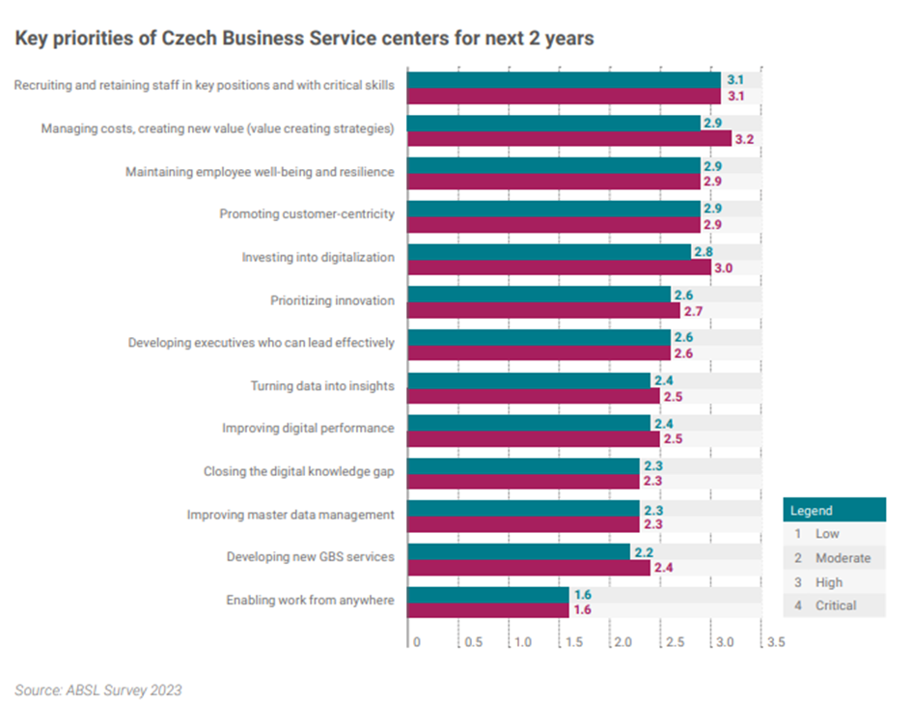

*Picture 2. ABSL report 2024 – Strategic Priorities for 2024*

Czech service centers must stay at the forefront of technological innovation to remain competitive. This involves integrating advanced digital solutions like artificial intelligence (AI), machine learning, robotic process automation (RPA), and advanced analytics. However, this rapid technological evolution requires continuous upskilling of employees and investment in new tools and platforms. As the centers integrate new digital solutions, talent acquisition strategies should focus on hiring individuals with a growth mindset, looking for candidates who embrace change, are tech-savvy, and can quickly adapt to evolving tools and platforms.

The shift to remote and hybrid work models presents both opportunities and challenges. While these models offer flexibility and can enhance employee satisfaction, they also introduce complexities in communication, collaboration, and maintaining corporate culture. Service centers should prioritize communication tools, flexible workspaces, and policies that support employee well-being. Remote work can enhance work-life balance, but it also demands strong self-discipline and collaboration skills. There is a need to foster a sense of belonging through virtual team-building activities and providing clear guidelines for remote work expectations.

With increasing digitalization, cybersecurity becomes a critical concern. Service centers must continuously enhance their cybersecurity measures to protect sensitive data and maintain client trust against evolving threats. Talent acquisition should focus on hiring cybersecurity experts and professionals who understand risk mitigation. Employees need ongoing training to stay vigilant against cyber threats. The centers should recognize and reward employees who actively contribute to cybersecurity efforts and create a security-conscious culture.

Service centers face the challenge of balancing economic pressures with the need for sustainable and ethical business practices. Stakeholders are increasingly prioritizing environmental, social, and governance (ESG) considerations. Geopolitical uncertainties, including trade tensions and regulatory changes, can disrupt global business operations. Service centers must develop strategies to navigate these uncertainties effectively.

## The Impacts of Work from Home on Business Service Centers

The global shift towards remote work, accelerated by the COVID-19 pandemic, has significantly transformed business operations across various sectors, particularly in Business Service Centers (BSCs). As both employers and employees navigate this new landscape, the impacts of work from home (WFH) reveal a complex mix of benefits and challenges that are reshaping the future of work.

*Benefits for Employers*

For employers, one of the most profound benefits of WFH is the reduction in operational costs. Business Service Centers, which typically house large numbers of employees in centralized locations, have found that remote work allows them to downsize physical office spaces, leading to significant savings on rent, utilities, and maintenance. Additionally, companies can tap into a wider talent pool without geographic constraints, enabling them to hire highly skilled professionals from different regions, often at a lower cost than in major urban centers.

Moreover, WFH has been associated with increased employee productivity in many cases. Without the need for lengthy commutes and with greater flexibility in work hours, employees often report higher job satisfaction and better work-life balance, which can translate to enhanced performance and reduced absenteeism. Digital collaboration tools and project management software have further facilitated seamless communication and efficiency among remote teams as well as enhanced business continuity amid disruptions.

*Challenges for Employers*

However, the shift to remote work also presents several challenges. Maintaining company culture and fostering team cohesion become more difficult when employees are physically dispersed. Reduced employee engagement, stemming from the loss of personal connections among staff, can result in decreased productivity and increased turnover. Moreover, collaboration may become less effective due to fewer spontaneous interactions that foster relationships and spark new ideas.

Business Service Centers must invest in advanced cybersecurity measures to protect sensitive data in a remote environment, and there can be significant upfront costs associated with providing employees with the necessary technology and equipment.

*Benefits for Employees*

For employees, the benefits of WFH are manifold. The flexibility to work from home allows for a better balance between personal and professional lives, leading to improved mental health and job satisfaction. Eliminating the daily commute saves time and money, and remote work environments can often be customized to suit individual preferences, boosting comfort and productivity.

*Challenges for Employees*

On the flip side, remote work can lead to feelings of isolation and disconnection from the broader team and company. Employees may struggle with maintaining boundaries between work and home life, leading to potential burnout. Furthermore, not all employees have access to a conducive work environment at home, which can affect their productivity and well-being.

*Cost Optimization*

Cost optimization is a critical aspect of the WFH model for Business Service Centers. By reducing the need for extensive office space, companies can achieve significant cost savings. Additionally, expenses related to commuting, office supplies, and on-site amenities are minimized. However, these savings must be balanced against investments in digital infrastructure, cybersecurity, and employee support programs to ensure a smooth transition to remote work.

*The Hybrid Work Model*

According to the Hackett Institute, the right hybrid work model balances the advantages of remote work with the benefits of in-office collaboration. This model involves a strategic mix where employees split their time between working from home and being in the office. The Hackett Institute emphasizes the importance of maintaining flexibility, allowing employees to work remotely for tasks that require deep focus while utilizing office time for team collaboration, brainstorming sessions, and fostering corporate culture. This approach aims to optimize productivity, enhance employee satisfaction, and mitigate the challenges associated with fully remote work, such as cybersecurity risks and reduced personal connections among staff. [online]. Available on [Diploma Course 7: Service Partnering 2.0 - The Hybrid Work Model | ABSL Fusion (poweredbyhackett.com))](https://education.poweredbyhackett.com/learn/course/diploma-course-7-serivce-partnering-20/choosing-and-designing-a-site/the-hybrid-work-model?client=absl-fusion-2022&page=3)

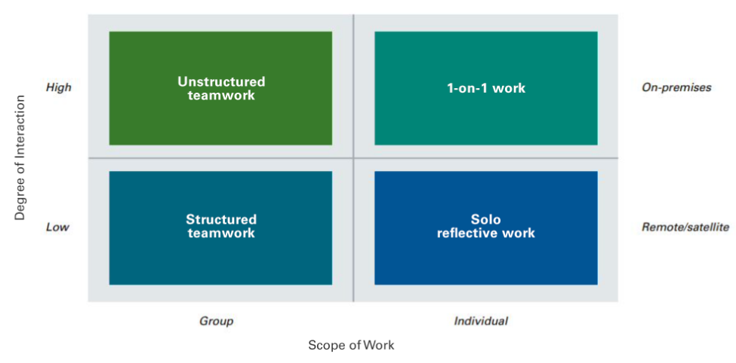*Picture 3. The Hackett Institute – The Hybrid Work Model*

## Future Predictions and Talent Strategies

*Increased Focus on Employee Well-being and Innovative Talent Management*

Service centers will place a greater emphasis on employee well-being to attract and retain skilled professionals. This involves offering flexible work arrangements, comprehensive health benefits, and robust career development opportunities. Companies will adopt innovative talent management strategies that prioritize work-life balance, mental health, and continuous professional growth. A focus on well-being and career development will make service centers more attractive to top talent. Providing a supportive and growth-oriented work environment will help retain employees and reduce turnover.

*Greater Emphasis on ESG Initiatives*

Service centers will prioritize sustainability and social responsibility as part of their business strategies. This includes reducing their environmental footprint, supporting community development, and ensuring fair labor practices. Emphasizing ESG initiatives will appeal to socially conscious employees who value working for organizations with strong ethical and environmental commitments. This can enhance employer branding and attract talent aligned with these values.

*Continued Investment in Training and Education*

To keep pace with evolving industry demands, service centers will invest heavily in training and education. This includes upskilling employees in new technologies, cybersecurity practices, and advanced analytics. Offering ongoing training and development opportunities will attract professionals eager to advance their skills and careers. A culture of continuous learning will help retain employees by providing clear pathways for career progression.

*A More Flexible Approach to Real Estate and Office Management*

Service centers will adopt a flexible approach to real estate and office management, balancing remote and in-office work. This includes creating collaborative spaces for in-person interactions while enabling remote work capabilities. Flexibility in work arrangements will appeal to a broader talent pool, including those who prefer remote work. It can also improve employee satisfaction and retention by accommodating diverse work preferences.

*Ongoing Advancements in Digital Technologies and Heightened Cybersecurity*

The adoption of advanced digital technologies will continue to transform service centers, driving efficiency and innovation. Concurrently, heightened cybersecurity measures will protect against emerging threats. Investing in cutting-edge technologies and robust cybersecurity will attract tech-savvy professionals and enhance the organization's reputation as a forward-thinking employer. Ensuring a secure work environment will also build trust and loyalty among employees.

The future of Czech service centers will be defined by their ability to adapt to rapid technological changes, manage evolving work models, enhance cybersecurity, balance economic and sustainable practices, and navigate geopolitical uncertainties. By addressing these challenges proactively, service centers can create dynamic, adaptable, and socially responsible environments that attract and retain top talent. Emphasizing employee well-being, sustainability, continuous learning, flexibility, and technological innovation will be key to success in the competitive global market. This strategic approach will ensure that Czech service centers not only meet the demands of the future but also thrive in it.

# Trends – Impact on the future talent pool

## Demographics trends

Thinking about the talent acquisition and retention strategies for the future, it is important to consider Czech population demographic trends which might impact considerably the talent pool available on the market. Two main demographics trends are being analyzed below: the current aging of the population and its potential development into gerontocracy, migration flows and the current Czech government strategy to address it.

### Aging of the population

The last available demographic overview produced by Czech statistical office were made in 2023 with the data up to the year 2022. The timeline is thus including the potential migration flows connected with foreigners’ movements linked to Covid-19, as well as flows related to the conflict in Ukraine.

The population in Czech Republic continued to grow. In the year 2022 the number reached 10 827 529 inhabitants, which is the highest number since World War II (Aktuální populační vývoj v kostce [online]. Available on: [Aktuální populační vývoj v kostce | ČSÚ (czso.cz)](https://www.czso.cz/csu/czso/aktualni-populacni-vyvoj-v-kostce). The growth was secured by the positive influx of foreigners, through the massive number of 276.617 incoming Ukrainians.

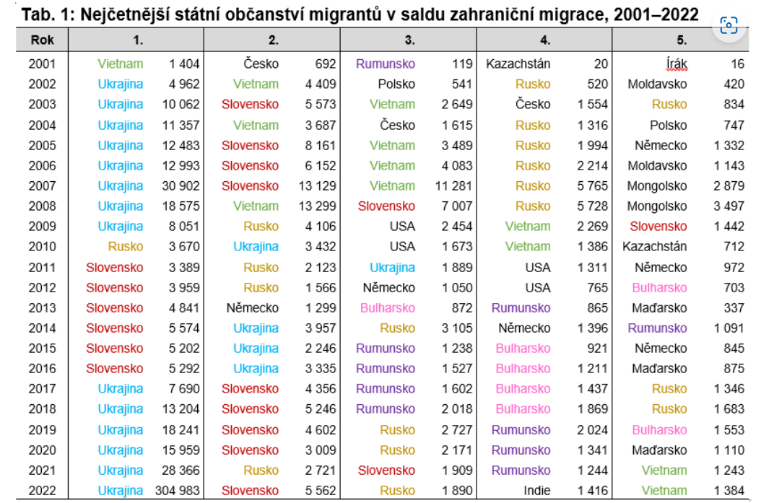

*Picture 4. Actuals migration to the Czech Republic*

However, without regards to the exceptional foreign immigration in 2022, the natural growth of Czech population is negative. The difference between newborn and deceased population is minus 18.000 every year and the natural increase in population continues to be negative since 2019 as per the figure 2. (Ibid.)

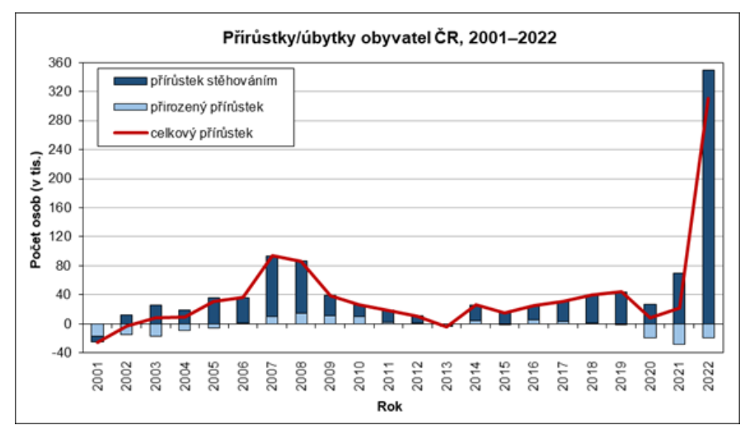

*Picture 5. Actuals Czech republic population*

At the end of 2022, the population of Czech Republic was composed of 16% of minors, 63% of productive population and 21% of seniors and the average life expectancy is 74 years for men and 80 years for women (Ibid.). The considerable Ukrainian immigration of predominantly women in productive age and their children had a slight impact on delaying the population aging, but with the current figures of negative population growth and the average life expectancy, the long-term prediction is not very optimistic. Unless there is an unforeseen change, by 2050 the working population will drastically decrease to 50% (Český statistický úřad: Stárnutí se nevyhneme [online]. Available on: [Stárnutí se nevyhneme | ČSÚ (czso.cz)](https://www.czso.cz/csu/czso/ea002b5947)).

With such population composition we might be able to predict couple of consequences on Czech political and economic system. First, the pressure on the state budget for pensions, healthcare and lack of workforce might lead to deep economic crisis. Second, most of the Czech population in senior and non-productive age will have a determining strength in voting priorities. We can expect that topics which are more relevant to elderly might be overruling topics relevant to younger generations. Depending on the ability of the political system to introduce potential quotas to secure the voice of the “young ones”, the Czech political representation might be risking falling into the gerontocracy.

### Migration flows

As mentioned above, the Czech Republic witnessed an exceptional immigration in last couple of years due to the Ukrainian conflict. It is difficult to predict the development in Ukraine in this moment - the result might either lead to further influx of Ukrainians or potentially lead to massive return of Ukrainians back to their homes once the conflict is over. On the picture 4. above we can observe, that apart from the Ukrainian citizens, the immigration flow from other geographies (traditionally Slovakia, Vietnam, Russia, or Romania) is decreasing. In order to compensate the negative population growth discussed above, it would be for the Czech Republic strategically convenient to develop a migration strategy. What is the status? Does Czech Republic have any?

To summarize the above, with exception of the Ukrainian exceptional situation, Czech Republic is long-term decreasing the number of newly incoming foreigners and the outdated migration policy of the government is not suggesting a change in the earliest timeline. With the latest attempt to open up to some of the specific non-EU citizens, we can positively hope that the political representation is aware of the demographic trends and will try to change the strategy going onwards.

Are there any other migratory flows which might impact the available manpower in the Czech Republic? Long term, climate migration can play a role and potentially positively contribute to the population growth, however it is difficult to estimate at this moment if the timeline would cover for the current population aging trend. (PBS News Hour: Climate change is already fueling global migration. [online]. Available on: [Climate change is already fueling global migration. The world isn’t ready to meet people’s changing needs, experts say | PBS NewsHour](https://www.pbs.org/newshour/world/climate-change-is-already-fueling-global-migration-the-world-isnt-ready-to-meet-peoples-needs-experts-say)

### The Czech Republic's migration policy strategy

Migration policy strategy The Czech Republic's migration policy strategy was adopted by the government in its resolution of **July 29, 2015**.

The material defines the key principles of the migration policy of the Czech state, sets goals in the given area for national and EU level and lists specific tools used to achieve them. Migration strategy covers the issue in its entire scope. It is divided into **seven** **corresponding thematic** modules individual core principles. In addition to state security, representing a cross-cutting element of the Strategy, these are the following thematic areas:

(1) integration of foreigners,

(2) illegal migration and return policy

(3) international protection,

(4) external dimensions of migration (including development and humanitarian aspects),

(5) free movement of persons within the EU and the Schengen area,

(6) legal migration and

(7) interconnectedness common EU policies in the field of migration.

**The migration policy strategy expresses the positions and priorities of the Czech**

**Republic:**

▪ ensure peaceful coexistence of citizens with foreigners, and thanks to effective integration prevent the emergence of negative ones social phenomena.

▪ ensure the safety of its citizens and effective law enforcement in ​​illegal migration, return policies and organized crime related to smuggling and human trafficking.

▪ fulfill their obligations in the field of asylum.

▪ to help refugees abroad and thus prevent further development of the migration crisis.

▪ maintain the benefits of free movement of persons within the EU and the Schengen area.

**▪ support legal migration in connection with the needs of the labor market;**

▪ meet their international and European obligations and actively participate in the search for common ones solution.

### Integration law

Czechia does not have a self-standing integration law. Measures in this field are based on [resolutions of the government](http://www.mvcr.cz/migrace/clanek/zakladni-dokumenty-k-integracni-politice-ke-stazeni.aspx" \t "_blank) [online]. Available on <https://www.mvcr.cz/migrace/clanek/zakladni-dokumenty-k-integracni-politice-ke-stazeni.aspx>.

### Conclusions and recommendations 1:

Czechia scores 50/100, in line with the average score of MIPEX country (49). Czech integration policies create as many obstacles as opportunities for integration. Czechia promotes a comprehensive approach to integration, but only goes halfway to actually guarantee equal rights, opportunities and security for immigrants. Czechia is starting to address these three critical dimensions, much like the ‘Top Ten’ MIPEX countries, but its policies still involve many more obstacles and less targeted support. Over the last five years, Czechia has increased its support for equal opportunities but done little to improve access to rights and long-term settlement for immigrants.

Czechia needs to invest more on those two dimensions, as they are weaker than in the average MIPEX country. Without greater support on all three dimensions, immigrants will remain invisible in public life and the Czech public will also continue to see immigrants more as threats than as opportunities. These weaknesses make immigrants and locals less likely to develop relationships and a common sense of belonging, trust and civic participation.

Internationally, the **‘Top Ten’ MIPEX** countries treat immigrants as equals, neighbors, and potential citizens, and invest in integration as a two-way process for society. Under these inclusive policies, both immigrants and the public are more likely to interact together and think of each other as equals.

Czechia is a regional leader. While Czechia’s integration policies are average for Europe, they are more advanced than in the other Central and Eastern Europe, such as the other Visegrad countries. For example, compared to Slovakia, Czechia has stronger policies in all policy areas except permanent residence and anti-discrimination. Czechia’s policies are similar to policies in Estonia or Malta. In contrast, policies are more advanced in neighboring Germany.

* **Labour market mobility.** *Halfway favourable*: Migrant workers may get trapped in lower-quality precarious jobs because, while they have opportunities to work, they face obstacles to access support and targeted trainings to improve their skills and careers.
* **Family reunification**. Slightly favourable: Separated families have right to reunite, if they can meet tougher requirements introduced in 2013.
* **Education**. Slightly favourable: Czechia leads Central Europe by improving its support to teachers and immigrant pupils since 2015, but more focus is needed on access, segregation and intercultural education.
* **Health**. Slightly favourable: Czechia leads Central Europe by taking the 1st steps to improve health information for migrants, but this support is ad hoc and access is limited
* **Political participation**. Unfavourable: A major area of weakness across Central Europe, immigrant groups in Czechia receive some funding, but limited opportunities to be informed, consulted or active in public life.
* **Permanent residence**. Halfway favourable: Non-EU residents can settle long-term, but would benefit from more flexible requirements and more secure status.
* **Access to nationality**. Slightly unfavourable: A major area of weakness across Central Europe, since 2013, restrictive requirements bar many immigrants and Czech-born children from acquiring dual nationality and common sense of belonging.
* **Anti-discrimination**. Slightly favourable: Potential victims of discrimination have limited awareness and trust of Czechia’s below-average 2009 Law, which is relatively young and weak, with gaps in law and weak equality body and policies.

1. ***Top 10 countries*** (average score: 75/100). Countries in this group represent the top ten out of the 56 MIPEX countries. They adopt a comprehensive approach to integration, which fully guarantees equal rights, opportunities and security for immigrants and citizens. Policies in these countries generally encourage the public to see immigrants as their equals, neighbours and potential citizens.

• Canada (80)  
• Finland (85)  
• New Zealand (77)  
• Portugal (81)  
• Sweden (86)

• Australia (65)  
• Belgium (69)  
• Brazil (64)  
• Ireland (64)  
• USA (73)

1. ***Comprehensive integration - Slightly favourable*** (average score: 60/100). These countries adopt a comprehensive approach to integration. However, policies in these countries are less comprehensive and less advanced than in the 'Top 10' MIPEX countries. In these countries, policies do not always encourage the public to see immigrants as their equals, neighbours and potential citizens.

• Iceland (56)  
• Israel (49)  
• Luxembourg (64)

**3.** ***Temporary integration - Halfway favourable*** (average score: 57/100). These countries provide immigrants with basic rights and equal opportunities, but not a secure future in the country. Policies in these countries encourage the public to see immigrants as their equals and neighbours, but also as foreigners rather than as potential citizens.

• France (56)  
• Germany (58)  
• Italy (58)  
  
**4. *Comprehensive integration - Halfway favourable*** (average score: 50/100). These countries do the minimum in all three dimensions as their polices go only halfway towards providing immigrants with equal rights, opportunities and a secure future.

• Czechia (50)  
• Estonia (50)  
• Korea (56)

## Technology trends

According to research, the global business process outsourcing (BPO) services market is predicted to increase at a 9.6% CAGR from USD 282.46 billion in 2022 to USD 586.92 billion by 2030 worldwide. (NEARSHOREFRIENDS: Business Process Outsourcing market: Key trends and predictions[online]. Available on: <https://nearshorefriends.de/business-process-outsourcing-market-key-trends-and-predictions/>).

This year, we are observing that job growth is slowing down due to increased automation and technology in business services in the Czech Republic. Some tasks are now handled by robots and automated systems. Despite this trend, the majority of centers plan to expand in the next two years, primarily by expanding their activities and exploring new regions. (ABSL: ABSL REPORT 2024 [online]. Available on: <https://absl.cz/report-2024/>).

An efficient branding strategy for future digital development should align with emerging technology trends. It would include utilizing data-driven insights to optimize marketing campaigns, investing in personalized customer experience, and establishing a strong online presence across multiple platforms. Additionally, leveraging emerging technologies. Some key trends to consider are:

1. **Personalization**: Tailor your branding message to individual consumers based on their preferences, interests, and behavior.
2. **AI and Automation**: Utilize artificial intelligence and automation technologies to enhance customer experiences and streamline operations.
3. **Augmented Reality and Virtual Reality**: Explore opportunities to create immersive brand experiences through AR and VR technologies.
4. **Social Media and Influencer Marketing**: Leverage social media platforms and collaborate with influencers to engage with your target audience in an authentic and relatable way.
5. **Sustainability and Corporate Social Responsibility**: Incorporate sustainable and socially responsible practices into your branding to appeal to environmentally conscious consumers.

**Remember, staying up to date with technology trends and adapting your branding strategy accordingly can help you stay ahead of the competition and resonate with your target audience**.

### EU’s Technology trend: The rise and fall of hardware versus software.

Over the past 20 years, the European tech industry has seen a significant shift from hardware to software and services. At the start of the millennium, hardware made up 61% of tech sales, but by 2021, this had dropped to 33%, reflecting the growing importance of software and services, whose revenues have nearly quadrupled since 2000 due to digitization. The rising demand for digital services and complex IT solutions, especially in areas like data analytics, has fueled this shift.

Meanwhile, the hardware segment faced challenges, including price drops, declining consumer electronics, and competition from Asia, leading to modest growth until 2014. However, since then, hardware’s decline has stabilized, with its share of tech sales even increasing slightly. This recovery is driven by the need for hardware to support software and services and by a strategic shift towards B2B markets, helping to secure the segment's future.

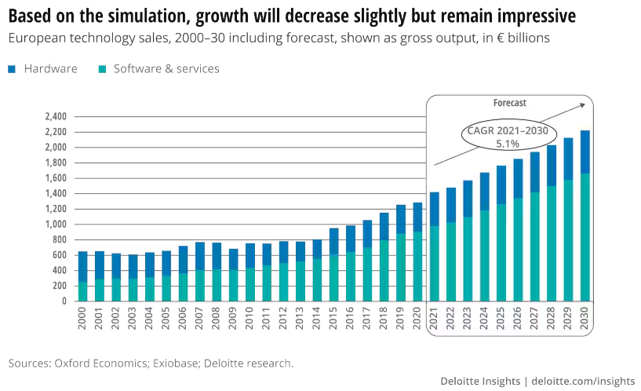

*Picture 6. European technology sales 2000 -2030*

European technology sales have seen substantial growth, driven by six key megatrends that are expected to continue fueling expansion through 2030:

1. **Interconnected Life and Business:** The Internet of Things (IoT) is rapidly expanding, with connected devices in Europe expected to nearly double by 2030. This growth is fueled by 5G and fiber infrastructure, which will enable advanced IoT services like assisted driving and remote healthcare. The tech industry will benefit from providing hardware and software solutions for these developments.
2. **Analytics and AI:** The increasing volume of data from interconnected devices will boost the demand for analytics and AI. These technologies offer significant benefits, such as AI-supported medical diagnoses, predictive maintenance, and energy-efficient traffic management. European tech companies, especially in software and services, are key players in these innovations.
3. **XaaS (Everything-as-a-Service):** The shift towards service-based business models continues to grow, particularly in the tech industry. XaaS, including AI-as-a-Service, is becoming more prevalent, making advanced technologies accessible to smaller companies and driving innovation.
4. **COVID-19's Digitization Boost:** The pandemic accelerated digitization across Europe, with long-term impacts on technology sales. There has been significant growth in digital media subscriptions and a push towards digitizing public services, healthcare, and education, benefiting consumer hardware sales.
5. **Supply Chain Resilience:** Recent supply chain disruptions, particularly in semiconductors, have highlighted the risks of relying on foreign manufacturing. European companies are increasingly focused on reshoring critical hardware production to enhance resilience, which will benefit the hardware sector in the long term.
6. **Future of the Metaverse:** While still developing, the metaverse holds significant potential as a future revenue driver. Technologies like XR and blockchain are central to its development. The metaverse could lead to a surge in demand for XR hardware and have industrial applications through digital twins. As the metaverse develops, there will be growing opportunities for talent skilled in XR, blockchain, and related technologies. Global service centers may need to build new capabilities in these emerging fields to capitalize on future growth opportunities.

### Conclusions and recommendations 2:

The shift towards software and services, coupled with the stabilization of hardware demand and the rise of new tech trends, will necessitate a broader and more diverse skill set within the tech talent pool. Global service centers will need to adapt by focusing on recruitment, training, and retention strategies that align with these evolving industry demands. It will be important to focus on:

1. **Increased Demand for Software Talent**: As the focus has moved from hardware to software, the demand for skilled software developers, data scientists, AI specialists, and IT service professionals has surged. Global service centers will need to attract and retain top talent in these areas to support the growing software and services sectors.
2. **Shift in Skill Requirements:** With the rise of Analytics, AI, and XaaS (Everything-as-a-Service), the required skill sets are evolving. Employees need expertise in advanced data analytics, AI technologies, cloud computing, and service-based models. Training and upskilling in these areas will be crucial for global service centers to stay competitive.
3. **Hardware Talent Demand Stabilization:** Despite the decline in hardware’s overall share, its recent stabilization and slight recovery—driven by the need for hardware to support advanced software solutions—means there will still be a consistent, though smaller, demand for hardware engineering talent. This may focus more on specialized areas such as IoT, 5G infrastructure, and XR (Extended Reality) hardware.
4. **Reshoring and Supply Chain Resilience:** The trend towards reshoring critical hardware production in Europe to improve supply chain resilience may lead to a modest increase in demand for hardware manufacturing and supply chain management professionals, though this will likely be less pronounced than the need for software and IT service skills.

## Industry-Specific BPO Trends

Industry-specific BPO trends vary depending on the sector and its unique needs. Here are some industry-specific BPO trends in our near future:

1. ***Healthcare BPO***

Telemedicine Support

Patient engagement

1. ***IT and Tech support BPO***

24/7 Tech Support

AI-driven Troubleshooting

Cybersecurity Services

1. ***E-commerce and Retail BPO***

Multichannel Customer Support

Personalization

1. ***Financial Services BPO***

Anti-Money Laundering Compliance

Fraud Detection

Regulatory reporting

1. ***Legal Process Outsourcing***

Document Review and Legal Research

Contract management & Visual contracting

Intellectual property services

From the above is visible that the future of Business Process Outsourcing (BPO) is poised for continued transformation driven by technological advancement, changing business needs, and global market dynamics. Automation and artificial intelligence (AI) will play an increasingly central role in BPO processes, with the potential to automate routine tasks across various industries.

## POLITICAL/LEGAL/IMPACT and ATTRACTIVITY OF EU

BPO is a fast-growing worldwide industry and in such cases also faces unique challenges one of which might be Political and Legal aspects.

We are witnessing that the entire world after the year 2000 is dramatically changing. Let’s highlight the global financial crisis in the 2000s in the USA. In Europe, the integration project gained a lot of traction at first and the EU even incorporated former Warsaw Pact members. It is important to mention also the newly established collaboration of those countries with NATO. Brexit has clearly demonstrated the inconsistency between politic leaders. The destabilizing impact of the recent COVID-19 pandemic was also very visible. There are several tensions in the Asia region as well. According to some political observers, current political leaders are dealing and living in the most challenging crisis since World War Two.

The current political situation evolved between the years 2022 –2024 impacted the BPO sector, too. In general, it can affect mainly offshore workers and new political regimes or sanctions may pass new laws that prohibit BPO in certain areas. For BPOs it is important to understand the laws of a particular area or country, to ensure that business practices don’t break any regulations, and what’s more it is important to have a clear plan in case that political situation changes. BPOs must constantly monitor the regulatory environment across all jurisdictions where they operate and be prepared to quickly adapt their policies, procedures, and service delivery strategies to ensure compliance.

According to Global Piece Index from 2024 (GPI, Vision of humanity [online]. Available on:<https://www.visionofhumanity.org/maps/#/.Available).> Czech Republic is considered one of safest and politically stable country in the world.

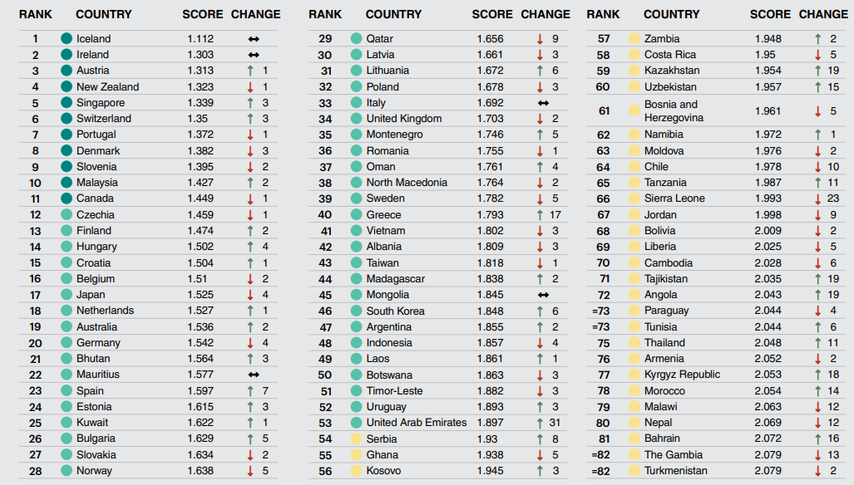

*Picture 7. GPI 2024*

### Gerontocracy

Population in the Czech Republic but even worldwide getting older and their living conditions are better. There is a visible decrease in mortality and birthrate, especially in advanced economies. Another aspect is that as the population is getting older, this might impact the election results and political preferences of votes and potentially this can impact also the BPO business in current countries.

According to the magazine Hospodářské noviny (HOSPODÁŘSKÉ NOVINY, Víkend [online]. Available on <https://vikend.hn.cz/c1-67341800-nastava-vek-gerontokracie-odkud-se-bere-proc-se-tyka-i-ceska-a-kam-nas-muze-zavest>) the gerontocracy in the politics might have an impact on the political situation in the respective country also political decisions and directions might be weak and going against worldwide trends. It is a known fact that in the most impactful world countries, leaders have crossed the age of 70 years and even more.

Staying in the EU is important for the collaboration and success in the Czech Republic. It is important to focus on the young generation and interact at a very early stage, investing time into the collaboration between schools and BPOs. In general, it is important for the BPO to do business outside standard groups. It is crucial to speed up the collaboration between the government and BPOs and focus on cybersecurity permissions and the entire cybersecurity topic. According to the ABSL report 2024, the top 5 priorities of government activities are very similar to the goals of our BPO's future goals and interests.

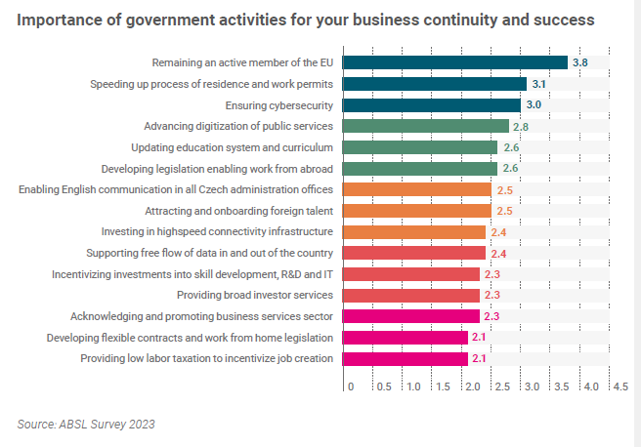

*Picture 8. ABSL report 2023 : Government activities*

### National strategy of the Czech Republic for 2030

It is also important to mention that Czech government approved the national strategy for artificial intelligence and their priorities to 2030. (MPO, Rozcestník, [online]. Available on: <https://www.mpo.gov.cz/cz/rozcestnik/pro-media/tiskove-zpravy/cesko-jako-technologicky-lidr--vlada-schvalila-narodni-strategii-umele-inteligence-cr-2030--282255/).>

Strategy includes 7 top priorities to focus on:

1. Research & Development, innovation – extension of research infrastructure, international collaboration, focus on AI are key goals.
2. Education – focus on new generation, transformation of educational process by using AI, support new talents.
3. Skilled workforce on the market and interaction with AI – flexible working environment, extend technological literacy towards Czech citizens, retrain and repurpose educational programs.
4. Ethical and legal aspects - Ethical and legal aspects of AI are crucial for building public trust and protecting individuals' rights. It is necessary to ensure effective legislation, establish ethical codes for developers and users, establish oversight bodies, and promote ethical use of AI.
5. Security aspects - ethics and security by using AI, data protection, create strong strategies against cyberattacks. Involve Czech Republic in security standard creation on the international level.
6. Industry grows with AI connection or usage - AI offers to the companies a great potential to increase productivity, savings and new innovations. Key factor is to support programs and companies like start-ups to grow in the AI area.
7. Public administration – focus on effectiveness and simplification of standard manual operations in public admin. Educate public administration to flexible and swift decision making. Training public admin staff, digitalization.

The National Strategy for Artificial Intelligence (NAIS), which provides a strategic framework for the development and utilization of trustworthy AI in the Czech Republic, will put the Action Plan into practice. This plan will include specific initiatives such as grant programs, manuals for businesses, retraining courses, and the implementation of new AI solutions. Its current form was prepared by the Ministry of Industry and Trade (MPO), in collaboration with the managers of key areas, and will be submitted to the government as part of the Implementation Plans for Digital Czech Republic. In this document, the ministry will support the current necessity of AI development as a strategic technology, for example through the **TWIST program**. The Action Plan will include investments in projects amounting to approximately 19 billion Czech koruna and will be annually updated to respond to the changing environment.

### Location and EU attractivity for investors

According to ABSL report (2024, p.28,31)., BPO centers in the Czech Republic highly value key factors crucial for their businesses, including safety, quality of life, infrastructure, cultural factors and geography. The Czech centers emphasize these factors along with cultural proximity to markets, a substantial talent pool, and access to necessary language skills. However, slightly lower scores are assigned to the availability of talent pool and cooperation with local authorities. Among these, the talent pool and securing highly qualified staff emerge as the most challenging aspects for centers, turning the market into a highly competitive landscape in this regard. Czech Republic carved out a reputation as an outsourcing powerhouse, particularly in information technology and related services. In June 2023 there were 1717 new technology – related jobs posted. Whether it’s software development, IT recruitment, or other outsourcing needs, Czech Republic offers a valuable combination of talent and resources to drive success for companies looking to optimize their operations and expand their global footprint.

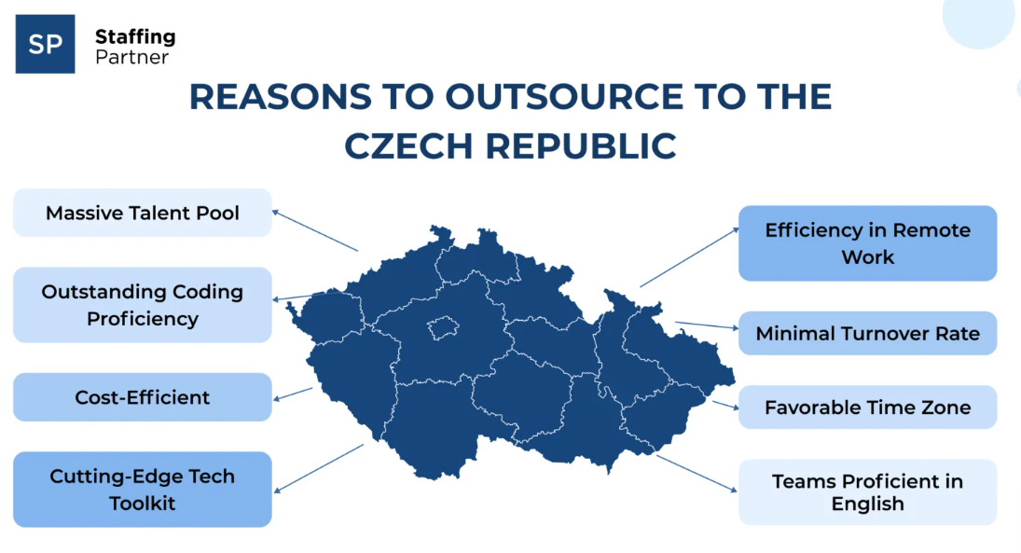

*Picture 9. Reasons to outsource to the Czech Republic*

**LOCAL COMPETITION**

If we consider the competition on the local market between BPO centers around cities in the Czech Republic, seems that the situation is stable. Despite Brno in certain areas achieving greater results than Prague (ABSL 2024, p.28).

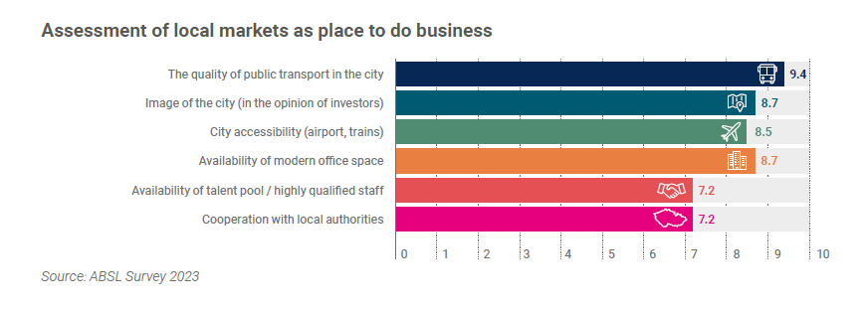

*Picture 10. ABSL report – Assessment of local markets to do business*

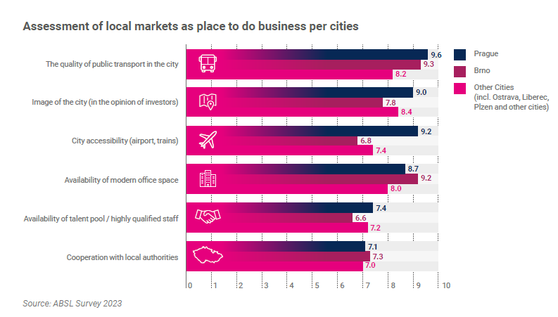

*Picture 11. ABSL report - Assessment of local markets to do business per cities*

**EU attractivity for investors**

According to EY Attractiveness survey (2024,p.6) (EY, Attractiveness survey, [online],visible on:https://www.ey.com/content/dam/ey-unified-site/ey-com/en-gl/campaigns/foreign-direct-investment-surveys/documents/ey-attractiveness-survey-06-2024-v3.pdf) the macroeconomic and geopolitical climate caused FDI (Foreign direct investment) in Europe to decline in 2023 for the first time since 2020. To maintain Europe’s appeal to foreign investors, policymakers must consider the current factors that influence investment decisions as Liquidity of financial markets, strength of the domestic market and cost of energy. But in the next three years, investors perceive the main risks for Europe’s attractiveness to be increased:

1.regulatory burden – constantly new regulatory initiatives encompassing carbon disclosure, supply chain, data protection and safe use of AI. Investors are worried that expanding regulatory framework will stifle European business growth.

2. volatile energy prices and energy supply issues – energy crisis of the past two years. Should investors expect some more?

3.political instability – there is a big worry about European elections, rising social tensions and political radicalism at the local level.

Despite this fact, Europe continues to be an attractive investment destination over the long term.

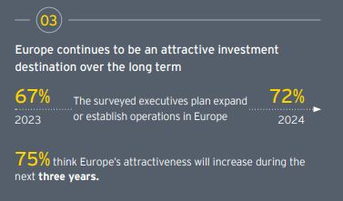

*Picture 12. European investment destination*

In general, foreign investors say that policymakers could focus on a total of nine areas to be constantly monitored, improved and solved.

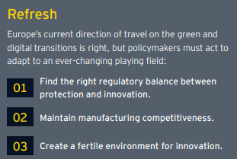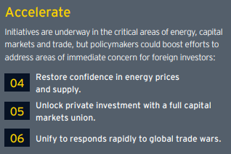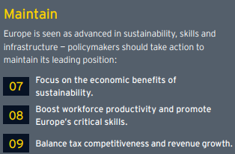

*Picture 13. Nine areas of focus in Europe*

Where should Europe concentrate its efforts to maintain its competitive position in the global economy?

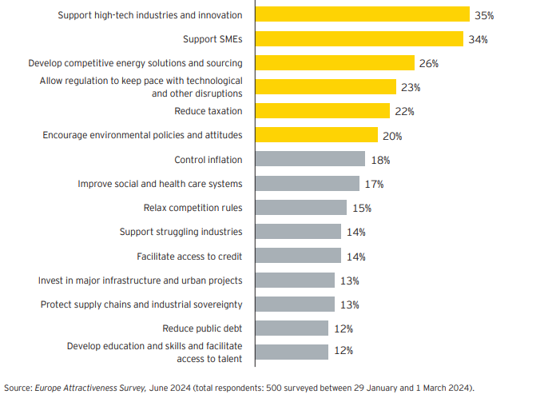

*Picture 14. : European effort concentration*

### Conclusions and recommendations 3:

1. It is more than evident that there is a need to establish regular discussion with the political leaders and emphasize the importance of collaboration. Show the interest to grow and bring new business to the Czech Republic and ensure that there will be good conditions for BPOs to enlarge their activity.

2. Focus on the young generation and start to interact with them already during their studies, help to share their future working possibilities. Create pressure on schools to consider different studying programs and learning opportunities for students. One of those might be the connection with **Junior Achievement** organization (<https://www.jaworldwide.org/>) focused on the young generation and integration in the current business market. Bring more talents not only to offices but also to industries and support skilled workforce on manufacturing sites.

3. Focus on cybersecurity and invest funds to improve cybersecurity standards.

4. Focus and extend possibilities for digitalization and artificial intelligence.

5. Share BPO ideas and insights regarding simplification rules for BPO business in the Czech Republic with the ABSL or other BPOs. This can help to have a strong voice towards government and create better conditions for the BPO organizations.

6. Support new start-ups - many young companies have the vision and knowledge but are seeking a strong partner to connect with. They are also probably more open to different possibilities, and willing to take a risk to be successful in the market. They can bring a lot of innovative ideas to your business.

## Main Economic Takeaways for Czechia

### **EU Green Deal Industrial plan impact:**

The Green Deal Industrial Plan is necessary to ensure that the EU can meet its ambitious climate goals while maintaining industrial competitiveness and creating economic growth and quality jobs.

Key Takeaways:

1. **Climate Neutrality Goal:**

The European Green Deal aims to make Europe the first climate-neutral continent by 2050, with a significant intermediate goal of reducing net greenhouse gas emissions by at least 55% by 2030 compared to 1990 levels.

1. **Support for Green and Digital Transitions:**

The EU's industrial strategy focuses on transitioning to a green and digital economy, enhancing global competitiveness, and ensuring strategic autonomy.

1. **Policy Framework and Alliances:**

The EU has implemented ambitious regulations and launched alliances in sectors like batteries, raw materials, solar, hydrogen, and circular plastics to support industrial cooperation and green investments.

1. **Response to Geopolitical Changes:**

The Plan addresses high energy prices and geopolitical shifts, such as the impact of the Russian war against Ukraine, by accelerating the net-zero industrial transformation.

1. **Economic and Job Growth:**

By ensuring access to key net-zero technologies, the Plan aims to create economic growth and quality jobs, strengthen competitiveness, and attract investments in green industrial innovation.

1. **Main Elements of the Plan:**
   1. Regulatory Environment: Simplified and coherent regulations to support rapid deployment of net-zero technologies.
   2. Funding Access: Increased investment opportunities while avoiding market fragmentation.
   3. Skills Development: Ensuring the workforce is equipped with the necessary green skills.
   4. Open Trade: Securing resilient supply chains through international cooperation and fair competition.
2. **Benefits for European Businesses and Society:**
   1. **Business Opportunities:** Businesses can scale their operations in the net-zero sector, benefiting from secure, affordable, and sustainable energy supplies and clean tech solutions.
   2. **Community and Environmental Benefits:** Quality job creation and a cleaner environment contribute to a sustainable market economy.

### **Tax Efficiency and Compliance**

1. **Understanding and Navigating Environmental Taxes:** GBS centers can support tax departments in navigating complex tax measures introduced to promote sustainability. By leveraging data analytics and digital tools, GBS centers can help companies stay compliant with new tax regulations such as the plastics tax, which varies across EU states. For example, Spain and Italy's planned plastics tax of EUR 0.45 per kilogram starting in 2023, compared to the EU's levy of EUR 0.80 per kilogram since 2021, highlights the need for precise and localized tax management.
2. **Energy Taxation Directive:** The reform of the Energy Taxation Directive (ETD) will increase administrative tasks for tax departments. GBS centers can streamline these processes by adapting contracts and IT systems, preparing tax returns, and managing tax reliefs, thereby mitigating the financial and operational burdens on companies.
3. **Carbon Border Adjustment Mechanism (CBAM):** GBS centers can assist companies in managing the complexities of the CBAM, which requires certificates for certain CO2-intensive import goods. By handling the intricate details of production conditions for imported goods, GBS centers ensure compliance and prevent locational disadvantages for EU-based businesses.
4. **Enhanced ESG Reporting and Strategy**
   1. **ESG Data Management**: As ESG reporting becomes more critical, GBS centers can provide robust data management solutions to ensure accurate and comprehensive reporting. This includes integrating tax data into ESG reports, which is increasingly important for demonstrating corporate responsibility and sustainability efforts.
   2. **Sustainable Supply Chain and Transfer Pricing Models:** GBS centers can aid in the transition to more sustainable supply chains, which requires a reevaluation of transfer pricing models. They can analyze the impact on indirect taxes and customs duties, ensuring that the switch to sustainable value creation is economically viable and compliant with regulatory standards.
   3. **Work from Anywhere (WFA) Initiatives:** GBS centers can support the implementation of mobile working policies across borders. They can manage payroll tax and permanent establishment risks, enabling companies to adopt flexible working arrangements while remaining compliant with international tax laws.

In summary, the Green Deal Industrial Plan is essential for achieving Europe's climate.

neutrality goals, enhancing industrial competitiveness, and fostering sustainable economic growth and job creation. Business Service Centers (BSCs) can leverage their capabilities to align their agendas with many aspects of the Green Deal Industrial Plan. This alignment will enable the industry to lead the path to digitalized processes targeting environmental impact by centralizing processes in fewer locations and applying technologies such as AI and machine learning to logistics processes to reduce CO2 emissions, among other strategies.

To support the Green Deal Industrial Plan, it is imperative to transform manual transactional workloads into smart, efficient, digitalized, and analytics-driven tasks. This transformation should be driven by our tech profile, which focuses on creating quality jobs, enhancing competitiveness, and attracting investments in green industrial innovation.

### Conclusions and recommendations 4:

The GBS industry stands to gain significantly from aligning with the EU's 'Fit for 55' and Green Deal initiatives. By embracing digital transformation, enhancing tax compliance, and supporting ESG strategies. GBS centers can not only contribute to sustainability goals but also strengthen their role as vital partners in the global business ecosystem.

It is with no surprise that ESG Towards resilience lend 2nd on the Top 5 emerging trend in the ABSL 2024 report and as well the Digital transformation to support ESG have lend in 5th position:

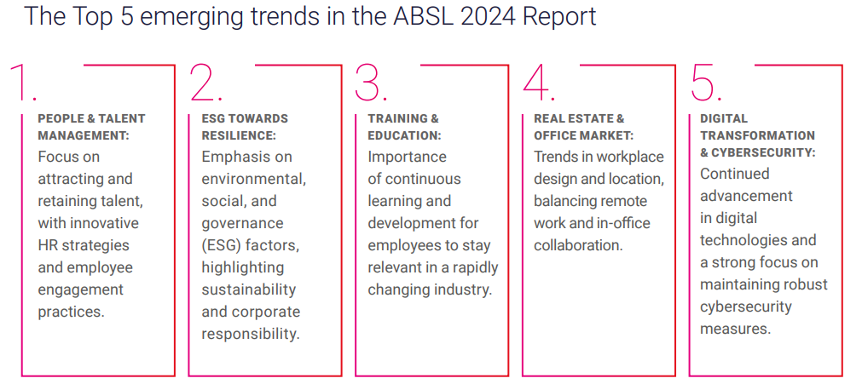

*Picture 15. ABSL report 2024 - Top 5 emerging trends*

### Benefits for the Global Business Service (GBS) Centers Industry from EU's

**Alignment with Sustainability Goals**

Reduction of CO2 Emissions: The goal of reducing CO2 emissions by 55% by 2030, as set by the 'Fit for 55' package, aligns with GBS centers' capabilities in optimizing and centralizing processes. By leveraging technologies such as AI and machine learning, GBS centers can enhance logistics processes to minimize CO2 emissions, thus contributing to the EU's broader decarbonization goals.

**Trend: NL example CO2 (mobility) reporting requirement delayed to 1 July 2024**

The CO2 (mobility) reporting requirement for employers with 100 employees or more will be postponed from 1 January 2024 to 1 July 2024. As of that date, employers will be required to keep and report data on employees' business travel and commutes between home and work. The concrete goal is a reduction of 1.5 megaton CO2 by 2030.

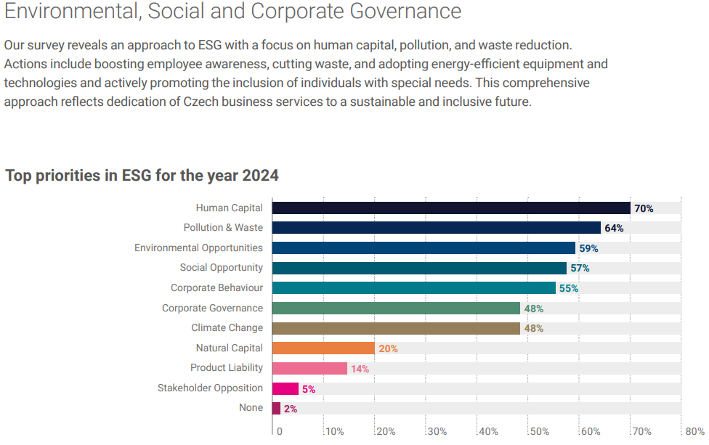

*Picture 16. ABSL report : ESG priorities 2024*

Europe faces ‘competitiveness crisis’ as US widens productivity gap:

According to Financial Times analysis, the labor productivity, which is most often calculated as a share of gross domestic product and employment, has been growing at approximately double the rate in the US over the long term. Moreover, in the last quarter of last year (Q4 2023), productivity fell by 1.2 percent year-on-year in the eurozone countries, while it rose by 2.6 percent in the United States over the same period.

Labor productivity ratio of countries versus the United States

A ranking of how European countries fare in labor productivity compared to the US. Its level of labor productivity here is 100 percent.

* Red line shows Czech Republic´s evolution.

*Picture 17 : Labour productivity in Czech Republic*

### Underlying issues:

**Resistance to risk taking:**

The behavior of companies, which are afraid of innovation also plays a role. And that's also because of the greater bet on security, especially in Central and Eastern Europe. Their ability to invest is quite conditioned by how much money they get for it or how much they believe that they can earn it back." In the US, this works completely the opposite. *"You don't have that protection in the United States, but it's offset by higher earnings while you're working,"*

This could easily be seen during covid. In the States, the number of immediate layoffs increased by leaps and bounds, but the increase in newly created jobs also came significantly faster after the economy opened up. In the Czech Republic, on the other hand, unemployment grew very slowly that first year and spread over time thanks to regulations.

The market is particularly harmed by strict rules in the area of ​​migration, which drives away foreign workers. On the contrary, the American market is more open to them. The European market cannot do without employing people from third countries, especially because of its other weakness – the rapid aging of the population.

Recommendation: To negotiate more flexible arrangements for migration with the Czech government

The Czech Republic is performing poorly also in this area within EU as can be seen by low number of startups, showing less investment in innovation and risk taking:

*Picture 18. Number of startups*

**Mobility:** According to economist Filip Pertold, the main pain point of the European labor market is the very low mobility of employees - that is, that they change jobs less often compared to Americans. At the same time, the very laws that regulate employment in the countries contribute to this. *"A large part of European labor laws is set against mobility. They give workers protection against dismissal, they have long notice periods,"* says Pertold, who is an adviser to the Minister of Labor and Social Affairs.

Leaving aside the last two years, when some changes are finally taking place, our legal system is more like the end of the 19th century and the first half of the 20th century.

Another reason for low mobility in Europe is also the difference in languages ​​in individual European countries. Compared to the United States, even moving to another country for work is less common.

Basically, a quarter of employees live paycheck to paycheck in the Czech Republic. A third of households are on the poverty line, meaning their liabilities are equal to their income. Although their job no longer fulfills them, they do not have the means to be unemployed for a few months and, for example, retrain for a new position. According to the analysis, 90 percent of Czechs look for another job only when they are still in the previous one.

*Picture 19. Housing affordability*

*Picture 20. Flexibility of work*

Recommendation: To stimulate the labor market, it is necessary to increase the availability of rental housing and improve the quality of transport infrastructure.

### Trend: Poor investment decisions in infrastructure

The Czech Republic has received over 1 billion crowns in contributions from the EU in 20 years. While the country issued them through a sector-wide decentralized subsidy system mainly to a large number of smaller regional and local projects, other countries such as Poland and Estonia used them differently. It turns out that while the Poles became the record holders for the number of highways built, the Czechs meanwhile built a record number of lookouts.

In comparison, the standard of living in the Czech Republic rose by 10 percent in 20 years, and in Poland by 40 percent.

While the state debt currently amounts to 44 percent of Czech GDP, other infrastructure debts make up 275 percent of GDP.

*Picture 21. Czech Republic debts*

Road / rail infrastructure

Compared to other countries, the Czech Republic is lagging in the construction of highways or high-speed railways. The Czech Republic in particular needs quality infrastructure for several reasons:

* 1. Czech Republic is the country with the largest volume of passenger transport in relation to GDP in the entire EU.
  2. At the same time, the Czech Republic is the fifth country in the EU in terms of GDP to the volume of freight transport.

Comparison with other EU countries:

In the area of road infrastructure in the Czech Republic, there are 17 meters of highways or expressways per square kilometer. In the western countries of the EU, however, this number is many times higher. In neighboring Germany it is 37 meters per square kilometer, in Belgium it is 58 meters and in the Netherlands even 75 meters.

There is also a deficit in the area of ​​rail transport. There are currently zero kilometers of high-speed railways in the Czech Republic. However, this deficiency should be reduced before long, and 700 kilometers should be built by 2050. In total, deficits in transport infrastructure should cost five trillion crowns, i.e. 68 percent of GDP.

*Picture 22-23. Digitization and Infrastructure: Road quality and Ev charging stations*

**Education infrastructure**

The most significant is the deficit in the field of education, science and research. In the Czech Republic, we have one of the lowest shares of people with university education within the EU.

In this area, specifically in education, we spend 4.6 percent of the gross domestic product. Countries that do it smarter and know it's a priority give one percentage point more. The situation is similar in science and research, where the top 10 EU countries invest 2 percent of GDP in comparison to the Czech Republic 0.8 percent.

Despite this deficit, the Czech Republic has very good results in terms of education. For example, to the results of the Program for International Student Assessment (PISA), which the Organization for Economic Cooperation and Development (OECD) uses to monitor the literacy of 15-year-old students in the basic disciplines, i.e. reading, math and science skills. In all categories, the Czech Republic is above average compared to other OECD countries.

Also, according to the analysts, there is even greater potential in higher education, where, for example, Charles University is 248th in the world.

*"If you wanted to build a global development center, would you build in a country that has a university ranked 250th in the world, or would you look for a place where there is a better chance of finding the best brains?".*

He also sees shortcomings in efficiency. Specifically, how quickly we can transform knowledge into higher added value. It is necessary to turn science and research first into patents and then into applied development and research. In the number of patents per million inhabitants, the Czech Republic is currently 34th in the world with 60.7 patents.

Approximately 132 billion crowns are missing annually to make up the deficit against the ten countries with the largest expenditures in these areas.

*Picture 24-25. Education & research*

**Population ageing**:

The funds that the Czech Republic will have to find to finance the pension system amount to 3.5 trillion crowns. That's roughly 48 percent of gross domestic product.

**Access to high-speed internet is also lacking**:

*Picture 26. Digitalization & Infrastructure: Internet coverage*

### Conclusions and recommendations 5:

If we want to stop the growth of our historical debt in infrastructure, there is an urgent need for the preparation, implementation and financial security of targeted and, above all, effective investments.

The starting point is to start reducing debt in infrastructure, introduce socially just and sustainable measures and invest targeted in key development areas of economic growth. And with the gradual growth of GDP, it is then possible to keep future state indebtedness within reasonable limits.

The Czech Republic has resources from the Modernization Fund, the National Reconstruction Fund and the Just Transformation Fund, but these will gradually weaken. In the next seven years, the Czech Republic will "only" give us 1 trillion crowns.

**Trend: Czech Republic is not getting close to the best countries in Europe.**

In the year-on-year comparison of the Prosperity and Financial Health Index, the Czech Republic dropped two places to 15th place in the EU.

The good news is that the industry was able to recover and come five percent above the level of the end of 2019. This is a better performance than neighboring Germany, but also better than the US. On the other hand, the neighboring Polish industry grew by more than a fifth.

Household consumption is nine percent lower than at the end of 2019. The decline in real consumption is by far the deepest of all 27 EU members. It's not just inflation to blame. Although prices in the Czech Republic increased by more than a third, the overall increase was not the highest in the EU. Consumer spending has been brought down by our bad mood. Czechs began to save more in difficult times and thereby deepened their difficult times even more. The good news is that the combination of falling inflation and improving confidence will boost real consumption.

When we compare the economic performance of the Czech Republic with the three best countries according to the Prosperity Index, we find that, according to EC data, we are at 77 percent of their level, measured by GDP in purchasing power parity and per capita. That's not a bad result at all. In 2000, we were at 57 percent. We are the highest of all the countries of Central and Eastern Europe. We have overtaken some countries of Western Europe, to be more precise Southwestern Europe. But in recent years, catching up has stopped. We do not have to speculate whether this is a temporary stoppage of convergence or a deeper structural problem. Rather, let's look at the sources of growth that we could use to accelerate prosperity.

If we compare the Czech economy with, for example, the Danish economy, which is at the top of the Prosperity Index, we find that production per worker (measured by purchasing power parity) is already comparable in both countries. But if we look at the end of the chain, i.e. the national income, it is suddenly 47 percent lower in the Czech Republic. The main problem is in added value. That is, in the ability to sell production with a sufficient margin. This explains 4/5 of the differences between the Czech Republic and Denmark. A fifth is associated primarily with the outflow of profits. By building Czech brands with global ambitions, we need to change the sign of the net dividend balance from negative to positive, just like Denmark has. Acquisitions of Czech companies abroad show that this is not an unrealistic plan.

**How to accelerate growth?** Long-term studies show that half of growth is driven by innovation, a quarter by human capital and 15 percent by infrastructure. Let us look at the people. Since 2010, Czech companies have been dealing with an aging population, i.e. a decline in the population aged 15-65. A simple solution is to import workers from abroad. However, this plan runs into the fact that population aging is a problem for the majority of countries in the EU. By 2050, the number of people aged 15-65 will drop by another tenth. In Slovakia, Ukraine, Poland, by about a fifth. It will become more and more difficult to "import" workers and we will fight for workers with richer countries.

In addition, the competitive advantage of the Czech workforce, i.e. lower wages, is gradually decreasing: the nominal wage is 40 percent of Germany. But if someone is looking for cheap labor, then in China they will get 27 percent or in India eight percent of Germany's wages. Wages in the Czech Republic will continue to grow thanks to demographics.

**Recommendation:** If we do not want to reduce competitiveness, we must increase productivity. On the one hand, this means to automate, digitize, and robotize. This will help us both to compensate for the missing workforce and to finance sustainable wage growth. At the same time, when people are a scarce resource, we must be able to attract talent from abroad, including high security in the Czech Republic, as shown by the Prosperity Index. And at the same time increase the quality of domestic human capital.

## Business shared services trend in Czech Republic

Czechia has become a hub for business process outsourcing, especially in the IT sector. With a thriving IT industry and a growing pool of skilled professionals, has become a go-to destination for companies seeking top-notch tech talent.

One of the key factors contributing to the country’s overall talent pool is its robust education system. Czech universities and institutes offer high-quality education in different fields. Czechia boasts a multilingual workforce with many professionals proficient in at least two languages. Our country also offers competitive salaries, and a massive talent pool spread across the state. (STAFFING PARTNER: Why outsource to the Czech Republic [online]. Available on: <https://staffingpartner.net/blog/outsource-to-czech-republic/>.

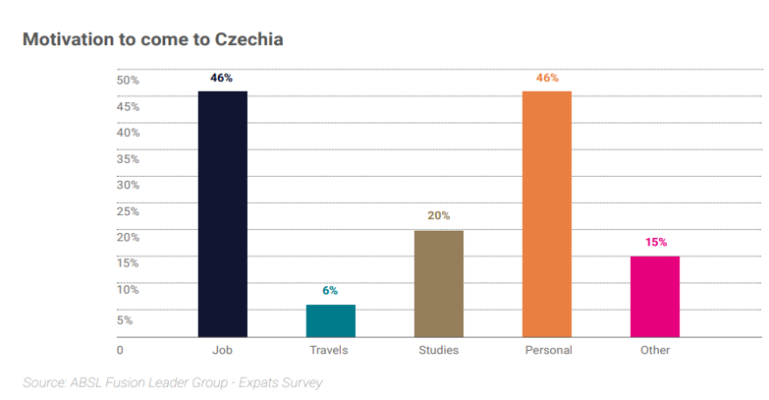

*Picture 27****.*** *ABSL report 2024 - Motivation of foreigners to come to Czechia*

The majority of Czech centers (59%) plan to expand their activities in the next 2 -3 years. The successful expansion is very much connected with some key factors mentioned below:

1. **Clear Value Proposition**: Define and communicate the unique value your organization offers to employees in terms of economic stability, growth opportunities, and competitive benefits.

2. **Targeted Employer Branding**: Tailor your brand message to attract employees who are seeking economic security, emphasizing factors such as job stability, financial rewards, and opportunities for advancement.

3. **Competitive Compensation Package**: Design a comprehensive compensation package that aligns with current economic trends, including competitive salaries, performance-based incentives, and attractive benefits.

4. **Skill Development and Training**: Emphasize your commitment to investing in employee growth by offering training programs and development opportunities that align with emerging economic trends and empower employees to stay relevant.

5. **Employee Well-being**: Prioritize the well-being and job satisfaction of employees, offering work-life balance initiatives, wellness programs, and an inclusive and supportive work environment.

6. **Thought Leadership and Industry Expertise**: Establish your organization as a leader in understanding and navigating economic trends, providing employees with access to relevant information, market insights, and networking opportunities.

### Conclusions and recommendations 6:

Remember, branding strategies should be dynamic, adapting to shifting economic circumstances.

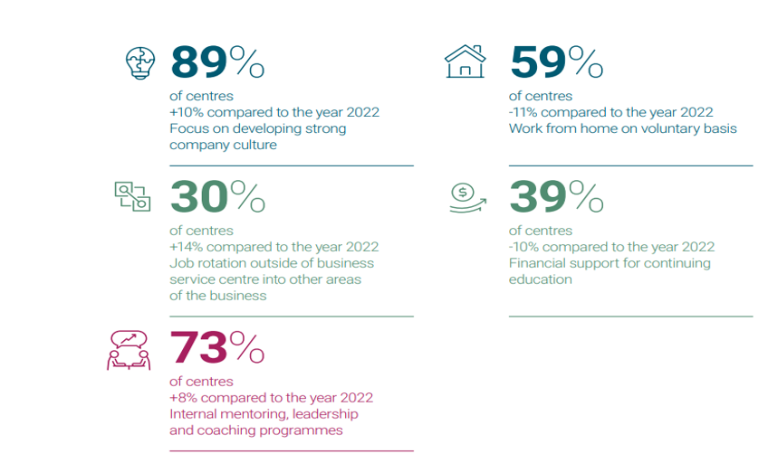

*Picture 28:**ABSL report 2024 – Retention Improvements and Company Benefits*

## What else can impact the future of Czech Service centers?

When devising an employer branding strategy for a shared service center, it's essential to consider also the potential one-off changes that could impact the center's operations. There are several potential one-off changes that could impact the future of Czech shared service centers:

**Regulatory Changes:** Any significant changes in regulations related to taxation, labor laws, data protection, or other areas could have a significant impact on the operations of shared service centers. For example, changes in tax laws could affect the cost-effectiveness of operating in the Czech Republic, while changes in data protection regulations could impact data processing and storage practices, and combined with new requirements for diversity and inclusion reporting could influence recruitment practices and necessitate compliance measures. Any changes in labor laws governing employment contracts, working hours, or benefits packages could influence how organizations structure their recruitment offers and negotiate terms with candidates. Updates to immigration laws or procedures for obtaining work permits could impact the ability of companies to recruit international talent and the requirements for sponsoring foreign workers. Regulations governing the use of temporary agency workers or contractors may change, affecting the flexibility of recruitment strategies and the use of temporary staffing solutions. Keeping abreast of these regulatory developments and their implications for recruitment practices will be essential for organizations operating in the EU. Recruiters should stay informed through industry associations, legal advisors, and official EU publications to ensure compliance and adaptability to evolving legislative requirements.

**COVID-19 aftermath:** The aftermath of the pandemic may continue to influence recruiting strategies, with a potential shift towards remote work and virtual hiring processes becoming more permanent. In fact, the most expected disruptive scenario by the end of 2025 according to the ABSL Report 2023 is the integrated pervasive hybrid workspace. (ABSL: ABSL REPORT 2023 [online]. Available on: <https://absl.cz/report-2023/>)

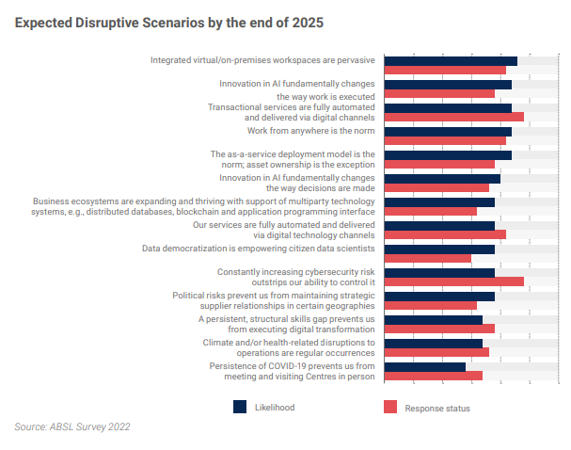

*Picture 29: ABSL report 2023 – Expected Disruptive Scenarios by the end of 2025*

**Global Events:** One-off events such as economic recessions, geopolitical tensions, or major disruptions (e.g., natural disasters, pandemics) can have far-reaching impacts on the business environment. These events can affect demand for services, supply chain stability, currency exchange rates, and overall business confidence, all of which can influence the operations of shared service centers. During **economic downturns**, organizations may implement hiring freezes or reduce their workforce, leading recruiters to focus on strategies such as internal mobility, talent retention, or hiring freezes. Conversely, during economic upturns, recruiters may need to ramp up hiring efforts to meet increased demand. **Geopolitical tensions** can disrupt global supply chains and affect business operations in certain regions. Recruiters may need to adjust their sourcing strategies to mitigate risks associated with geopolitical instability, such as diversifying talent pools or focusing on local recruitment to reduce dependency on international markets. **Natural disasters** such as earthquakes, hurricanes, or pandemics can disrupt local economies and infrastructure, impacting hiring activities in affected areas. Recruiters may need to prioritize workforce safety and well-being while implementing contingency plans to address staffing shortages or disruptions to recruitment processes. **Public health crises**, such as pandemics or outbreaks of infectious diseases, can necessitate remote work arrangements and virtual hiring processes to ensure employee safety and business continuity. Recruiters may need to leverage technology for virtual interviews, remote onboarding, and collaboration with distributed teams. Rapid **technological advancements**, such as automation, artificial intelligence, and digitization, are transforming the nature of work and the skills required in the workforce. Recruiters may need to adapt their sourcing strategies to attract candidates with in-demand technical skills or invest in training and development programs to upskill existing employees. According to the Labor Minister Marian Jurečka, it is expected that over the next seven to eight years, 300 000 jobs will be lost in the Czech Republic and 1 million positions will undergo significant changes to their job descriptions due to digitization. As a result, investment in retraining and education, especially digital skills, is necessary. (ČTK: 300,000 jobs could disappear from Czechia, retraining is needed [online]. Available on:[300,000 jobs could disappear from Czechia, retraining is needed - Prague, Czech Republic (expats.cz)](https://www.expats.cz/czech-news/article/300-000-jobs-could-disappear-from-czechia-retraining-needed))

The effects of **climate change**, such as extreme weather events, resource scarcity, and environmental degradation, can impact industries reliant on natural resources or vulnerable to supply chain disruptions. Recruiters may need to prioritize candidates with sustainability expertise or adapt recruitment strategies to support environmentally responsible practices. **Social unrest**, protests, or civil unrest can create uncertainty and instability in affected regions, impacting business operations and talent acquisition efforts. Recruiters may need to assess the safety and security of potential hires and implement measures to support diversity, equity, and inclusion in response to social movements and calls for social justice.

In response to these events, companies should maintain flexibility, resilience, and adaptability in their strategies to navigate uncertain and rapidly changing environments. Building robust networks, staying informed about global trends, and proactively addressing emerging challenges will be essential for recruiting success in the face of global events.

## Political and legal system in the Czech republic

Let’s mention also other reasons as political and legal that serve as the nation’s competitive advantage and drive the construction of SSCs. According to Ernst & Young European Attractiveness survey, Central and Eastern European region is always in the top three most favorite destinations of FDI inflow already from 2006 until now. Despite the financial crisis which has brought down the FDI points quite significantly, investors believe that investing into Central and Eastern Europe region will bring them profit in the future. Among such countries, the Czech Republic is one which is considered the best for investment. Czech Republic has very stable political system. Having joined the European Union, the Czech Republic has had to ensure that all the laws regarding data protection met the EU standards.

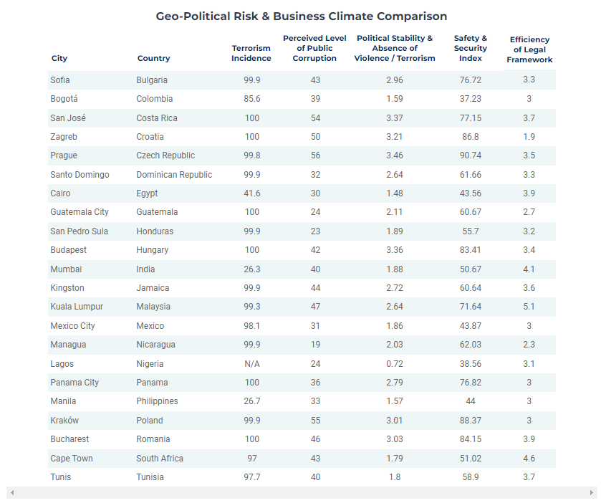

*Picture 30. European technology sales 2000 -2030*

Despite the fact, for many SSCs is important that Czech Republic is member of EU, and it is considered as the most critical factor for the success. 93% of the centers rank it as high or critical to their business continuity. While the Ukraine-Russian was conflict increased the importance of cybersecurity, which scored as the second most important activity by the Czech government that the centers need.

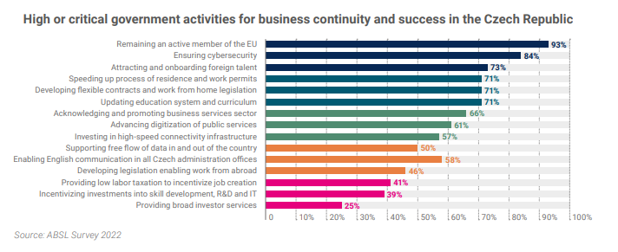

. *Picture 31. European technology sales 2000 -2030*

### Conclusions and recommendations 7:

**Selecting the Right Talent Pool Market for a Global Service Center; Universities**

To build a successful Global Service Center, it's crucial to target a talent pool that consists of young professionals, including students nearing graduation and recent graduates seeking their first career opportunities. These candidates are ideally suited for well-established Global Business Services (GBS) environments that offer robust learning and development opportunities, coaching and mentoring support, and a collaborative team-oriented culture. Such an environment provides the ideal conditions for a strong career start.

Establishing partnerships with local and international tech schools and universities is key to attracting top digital talent, including those with foreign language skills. These partnerships can facilitate internship programs, provide access to professional lectures from industry experts, and support participation in job fairs—all of which are highly effective strategies for acquiring and nurturing digital talent.

## Branding: Setting targets, budget, and resources

The budget needed for branding and talent acquisition marketing campaigns for a small or medium-sized enterprise (SME) can vary, however SMEs often allocate anywhere from $20,000 to $100,000 while larger enterprises would allocate $50,000 to $200,000 or more annually for comprehensive branding and talent acquisition marketing campaigns.

The budget expenditure should cover:

**Brand Development:**

1. Logo and Visual Identity
2. Costs for designing a professional logo and visual brand elements
3. Brand Guidelines:
4. Developing brand guidelines (including colors, fonts, imagery) for consistent brand representation
5. Website Development
6. Creating a user-friendly and mobile-responsive website

**Brand Awareness Campaigns:**

Digital Marketing: Budget for digital marketing activities such as pay-per-click (PPC) advertising, social media marketing, content creation, and email campaigns

Content Creation: Costs for creating engaging content (blog posts, videos, infographics) to build brand awareness

**Talent Acquisition Campaigns:**

Recruitment Advertising: Budget for job postings on relevant job boards, industry-specific platforms, and social media

Employer Branding: Investment in employer branding initiatives, including career page development, employee testimonials, and employer branding events

**Networking and Events:**

Networking Events: Budget for attending industry conferences, career fairs, and networking events

Sponsorships: Investing in sponsorships of relevant events or community initiatives

**Measurement and Analytics:**

Marketing Tools: Budget for marketing analytics tools and software to track campaign performance and measure ROI

HR system analytics: Budget for analytics of internally collected data

The budget does not include recruitment itself where if externally provided, the cost of a recruitment agency falls between 15% and 20% of the first-year salary of the candidate. In some cases, staffing agencies may charge as much as 25-30% for positions that require unique technical skills.

To achieve significant outcomes, one must approach the task with utmost seriousness and dedication. However, in life we experience certain limitations. For this reason, while budget availability is preferred, we also provide best practices for „No-cost branding and talent acquisition strategies “.

In case there is not enough stakeholder confidence, we recommend starting with no-cost branding and talent acquisition strategies and build stakeholder confidence together with budget over time based on the results.

**“No-cost branding and talent acquisition strategies”**

Use of LinkedIn and other social media platforms.

Hashtags and search filters are a great way to quickly find candidates on social networks such as LinkedIn looking for work in our industry. (#opentowork, #layoff,).

Career coaches / LinkedIn content creators sharing career tips and tricks are often in touch with tens of thousands of job seekers. Building strong relationships with career coaches can allow them to send candidates your way while also helping them help their clients land interviews faster, a win-win situation.

Completing company profiles or pages with relevant and engaging content on LinkedIn, Facebook, and Twitter.

Posting open roles, searching for, and messaging talent, and joining networking groups on LinkedIn.

Commenting on posts by individuals looking for work.

Promoting job openings and benefits of joining your team.

Highlighting team member success stories, testimonials, and workplace awards.

Producing and sharing videos that highlight your company culture and employer brand.

Responding to individuals who engage with your organization’s social media content by commenting on posts, resharing posts, or sending messages.

Building internal social media ambassador program

Leverage your internal success stories and engaged workforce

Developing a formal referral program, with incentives to encourage participation

Encouraging team members to share open roles on social media and other networks

Building a presence on social media via usage of internal resources

e.g. tiktok / Instagram / .. videos created by a marketing expert linking to job website

## Sustainment: Measure the success and react quickly

To measure success, it is highly recommended to implement and monitor KPIs and KRIs via comprehensive **talent acquisition funnel.** This enables a structured approach to the recruitment process, which allows organizations to attract, engage, and hire top talent effectively.



In order to achieve maximum value within the talent acquisition funnel, the best practice is to combine the data from the online data analytics tools with internal data collected via e.g. HR system.

As such, internal cooperation between dedicated branding / marketing and HR departments (incl. analytics) is recommended.

The data can serve both as key performance and key risk indicators as they show both the effectiveness / return on investment as well as identify gaps in the internal processes or strategy itself.

The top tools for evaluation of online marketing data:

1. **Google Analytics**: Google Analytics is a powerful and widely used web analytics tool that provides detailed insights into website traffic, user behavior, and conversion metrics. It offers various reports and features to track the performance of online marketing campaigns, including campaign tracking, goal tracking, and attribution modeling.
2. **Adobe Analytics:** Adobe Analytics is an enterprise-level analytics solution that offers advanced reporting and analytics features for tracking online marketing campaigns, customer behavior, and conversion paths across multiple channels.
3. **Matomo**: is an open-source web analytics platform that provides detailed insights into website and app performance. It offers features similar to Google Analytics but with a focus on data privacy and user ownership.
4. **Google Ads (formerly Google AdWords)**: If you're running paid search campaigns, Google Ads offers robust reporting and analytics features to track ad performance, keywords, ad groups, and conversions. You can analyze metrics such as clicks, impressions, click-through rate (CTR), conversion rate, and return on ad spend (ROAS).
5. **Facebook Ads Manager**: For social media advertising campaigns on Facebook and Instagram, Facebook Ads Manager provides comprehensive reporting and analytics tools. You can monitor ad performance, audience engagement, demographics, and conversion metrics, as well as create custom reports and track campaign objectives.

Talent Acquisition Funnel

1. **Awareness Phase**:
   * **Impressions**: Total number of times your ads or content were displayed.
   * **Reach**: Number of unique people who saw your ads or content.
   * **Traffic**: Number of visitors to your site or landing pages.
   * **Engagement Rate**: Interactions with your content relative to impressions or reach.
2. **Interest Phase**:
   * **Click-through Rate (CTR)**: The percentage of people who clicked on a link out of the total number of people who saw the link.
   * **Social Media Engagement**: Likes, comments, shares, and overall interactions on your social media posts.
3. **Consideration Phase**:
   * **Lead Generation**: Number of new leads collected through different channels
   * **Time on Page**: Average amount of time spent on key pages.
   * **Candidate Engagement Rate:** Measures the level of interaction candidates have with your recruitment content, such as responses to emails, participation in webinars, or engagement with social media posts.
   * **Qualified Candidate Rate**: Percentage of candidates who pass initial screening processes and meet the essential criteria for the role. This metric helps assess the effectiveness of your sourcing and initial assessment methods.
   * **Interview Booking Rate**: The ratio of qualified candidates who are scheduled for interviews. This indicates the success of your engagement efforts in motivating candidates to move forward in the process.
   * **Response Time:** The average time it takes for your recruiting team to follow up with candidates after their application or after they have been identified as qualified leads. Faster response times can improve candidate experience and engagement.
   * **Drop-Off Rate:** The percentage of candidates who withdraw from the process voluntarily or fail to move past this stage for other reasons. This can help identify potential issues in the candidate journey that need addressing.
   * **Progression Rate:** Measures the proportion of candidates moving from the consideration phase to the interview or assessment stages. It helps gauge the effectiveness of your nurturing strategies in advancing candidates through the funnel.
4. **Conversion Phase**:
   * **Offer Acceptance Rate:** Measures the percentage of job offers that are accepted. It reflects the effectiveness of your recruitment process and the attractiveness of your offers.
   * **Time to Fill:** The average amount of time it takes from job posting to job acceptance. This metric indicates the efficiency of your recruitment pipeline.
   * **Candidate Conversion Rate:** The ratio of candidates who move from the interviewing stage to receiving a job offer.
   * **Interview-to-Offer Ratio:** The number of candidates interviewed compared to the number of offers extended. This helps assess the effectiveness of the interview process.
   * **Cost Per Hire:** Total recruitment costs divided by the number of hires. It includes expenses like advertising, recruiter fees, and technology costs.
   * **Quality of Hire:** Assesses the impact of new hires on the organization, typically measured after a certain period, based on performance and productivity metrics.
   * **Applicant Drop-off Rate**: Percentage of candidates who start but do not complete the application process. This can indicate problems with the application process or candidate engagement strategies.
   * **Candidate Experience:** Measured through surveys with candidates who went through the hiring process, this metric gauge’s satisfaction with the recruitment experience, regardless of the outcome.
5. **Loyalty Phase**:
   * **Retention Rate:** Measures the percentage of employees who remain with the company over a given period. High retention rates indicate successful onboarding and employee satisfaction.
   * **Employee Net Promoter Score (eNPS):** Gauges employee loyalty and their likelihood of recommending the company as a great place to work.
   * **Internal Promotion Rate:** The rate at which employees are promoted within the organization. This metric can indicate the effectiveness of professional development and internal career progression opportunities.
   * **Training Completion Rate:** Percentage of employees who complete training programs provided by the employer. This can measure engagement and growth within the company.
   * **Employee Engagement Score**: Assessed through surveys, this score evaluates the level of employee engagement and commitment.
   * **Turnover Rate of High Performers**: Identifies the turnover rate specifically among top-performing employees, which can indicate the overall health of talent management strategies.
   * **Average Tenure:** The average length of time employees stay with the company, providing insights into loyalty and satisfaction.
   * **Employee Net Promoter Score (eNPS)**: A measure of employee satisfaction and loyalty.
6. **Advocacy Phase**:
   * **Employee Referral Rates:** Measures the percentage of hires that come from employee referrals. High rates can indicate strong employee belief in the company as a great place to work.
   * **Social Media Advocacy:** Tracks engagement metrics on posts shared by employees related to their work or the company, such as likes, shares, and comments.
   * **Participation Rate in Employer Branding Initiatives**: The percentage of employees actively participating in employer branding activities, such as testimonials, case studies, or recruitment events.
   * **Brand Ambassador Activity Levels:** Frequency and reach of employee-driven activities that promote the employer brand, such as speaking engagements or participation in industry panels.
   * **Impact of Employee-Generated Content:** Engagement and reach metrics for content created by employees about the company, such as blog posts, videos, or social media updates.

React quickly and protect your brand!

Overall, risk management plays a vital role in shaping the attractiveness of digital workforce strategies by mitigating risks, ensuring compliance, maintaining security and privacy, and building trust and confidence among potential digital talent. Organizations that prioritize risk management are better positioned to attract and retain top digital talent in today's competitive labor market.

### Conclusions and recommendations 8:

**Respect the golden hour**

The "golden hour" in crisis communication refers to the critical first hour after a crisis or emergency occurs. During this initial period, it's crucial for organizations to respond swiftly and effectively to manage the situation and minimize negative impacts. Here's why the golden hour is significant:

1. **First Impressions Matter**: The way an organization responds during the golden hour sets the tone for how the crisis will be perceived by stakeholders, including the public, media, employees, customers, and investors. A prompt and well-executed response can help build trust, credibility, and confidence in the organization's ability to handle the situation.
2. **Prevent Escalation**: Acting quickly during the golden hour can help prevent the crisis from escalating further. By addressing the situation promptly, organizations can contain the crisis and prevent it from spreading or causing additional harm.
3. **Information Gathering**: The golden hour is a critical time for gathering accurate information about the crisis, assessing the extent of the impact, and understanding the underlying causes. This information forms the basis for decision-making and communication strategies moving forward.
4. **Coordination and Mobilization**: During the golden hour, organizations need to mobilize their crisis management team, coordinate response efforts, and allocate resources effectively. Clear lines of communication and decision-making protocols are essential to ensure a cohesive and coordinated response.
5. **Communication Planning**: Effective communication is key during the golden hour. Organizations should develop communication plans and strategies for disseminating accurate information to stakeholders, addressing their concerns, and managing the narrative surrounding the crisis.
6. **Stakeholder Engagement**: Engaging with stakeholders early on is critical to maintaining trust and transparency. Organizations should communicate proactively with affected parties, including employees, customers, partners, and the media, to keep them informed and address their needs and concerns.

### Conclusions and recommendations 9:

Prepare canned responses:

"Canned responses" in crisis communication refer to pre-prepared messages or templates that organizations can use to quickly respond to common questions, inquiries, or situations during a crisis.

These canned responses serve as a foundation for communication during a crisis, allowing organizations to respond promptly, consistently, and effectively across various channels while ensuring accuracy and alignment with the organization's messaging and objectives. However, it's essential to customize these responses as needed to fit the specific context and nuances of each crisis situation.

### Conclusions and recommendations 10:

Train your crisis committee and branding managers regularly

We recommend performing a crisis communication testing at least 1 per year with a gamification aspect to engage stakeholders via prepared scenarios and situations to monitor how the stakeholders would react. This can serve as a learning session to build on or improve canned responses, cooperation with authorities as well as other internal stakeholders.

## References

Guide: [A Quick Guide to Harvard Referencing | Citation Examples (scribbr.co.uk)](https://www.scribbr.co.uk/referencing/harvard-style/)

1. STAFFING PARTNER: Why outsource to the Czech Republic [online]. Available on: <https://staffingpartner.net/blog/outsource-to-czech-republic/>
2. ABSL: ABSL REPORT 2024 [online]. Available on: <https://absl.cz/report-2024/>
3. ABSL: ABSL REPORT 2023 [online]. Available on: <https://absl.cz/report-2023/>
4. Team Job Spin: Czech Job Market Trends in 2024: <https://www.jobspin.cz/2023/10/czech-job-market-trends-in-2024-ai-impact-emerging-job-types-and-employment-outlook/)>
5. Hackett Institute: Fusion Programme [online]. Available on [Diploma Course 7: Service Partnering 2.0 - The Hybrid Work Model | ABSL Fusion (poweredbyhackett.com))](https://education.poweredbyhackett.com/learn/course/diploma-course-7-serivce-partnering-20/choosing-and-designing-a-site/the-hybrid-work-model?client=absl-fusion-2022&page=3)
6. Aktuální populační vývoj v kostce [online]. Available on: [Aktuální populační vývoj v kostce | ČSÚ (czso.cz)](https://www.czso.cz/csu/czso/aktualni-populacni-vyvoj-v-kostce)
7. Český statistický úřad: Stárnutí se nevyhneme [online]. Available on: [Stárnutí se nevyhneme | ČSÚ (czso.cz)](https://www.czso.cz/csu/czso/ea002b5947)
8. PBS News Hour: Climate change is already fueling global migration. [online]. Available on: [Climate change is already fueling global migration. The world isn’t ready to meet people’s changing needs, experts say | PBS NewsHour](https://www.pbs.org/newshour/world/climate-change-is-already-fueling-global-migration-the-world-isnt-ready-to-meet-peoples-needs-experts-say)
9. MVCR: MVCR Migrace[online]. Available on <https://www.mvcr.cz/migrace/clanek/zakladni-dokumenty-k-integracni-politice-ke-stazeni.aspx>.
10. NEARSHOREFRIENDS:,Business Process Outsourcing market: Key trends and predictions[online]. Available on: <https://nearshorefriends.de/business-process-outsourcing-market-key-trends-and-predictions/>
11. GPI:Vision of humanity [online]. Available on :[https://www.visionofhumanity.org/maps/#/.Available).](https://www.visionofhumanity.org/maps/" \l "/.Available)." \t "_blank)
12. (HOSPODÁŘSKÉ NOVINY, Víkend  [online]. Available on <https://vikend.hn.cz/c1-67341800-nastava-vek-gerontokracie-odkud-se-bere-proc-se-tyka-i-ceska-a-kam-nas-muze-zavest>)
13. MPO, Rozcestník, [online]. Available on: <https://www.mpo.gov.cz/cz/rozcestnik/pro-media/tiskove-zpravy/cesko-jako-technologicky-lidr--vlada-schvalila-narodni-strategii-umele-inteligence-cr-2030--282255/).>
14. EY, Attractiveness survey, [online], visible on :https://www.ey.com/content/dam/ey-unified-site/ey-com/en-gl/campaigns/foreign-direct-investment-surveys/documents/ey-attractiveness-survey-06-2024-v3.pdf)
15. ČTK: 300,000 jobs could disappear from Czechia, retraining is needed [online]. Available on:[300,000 jobs could disappear from Czechia, retraining is needed - Prague, Czech Republic (expats.cz)](https://www.expats.cz/czech-news/article/300-000-jobs-could-disappear-from-czechia-retraining-needed))